## *What Money Can’t Buy*

It is not difficult to glean inspiration from the depth of insight of Morgan Housel, the author of *The Psychology of Money*. He has a knack for illuminating devastating human truths from a little book with a big metaphorical mirror—in which all of us are welcome to gaze.

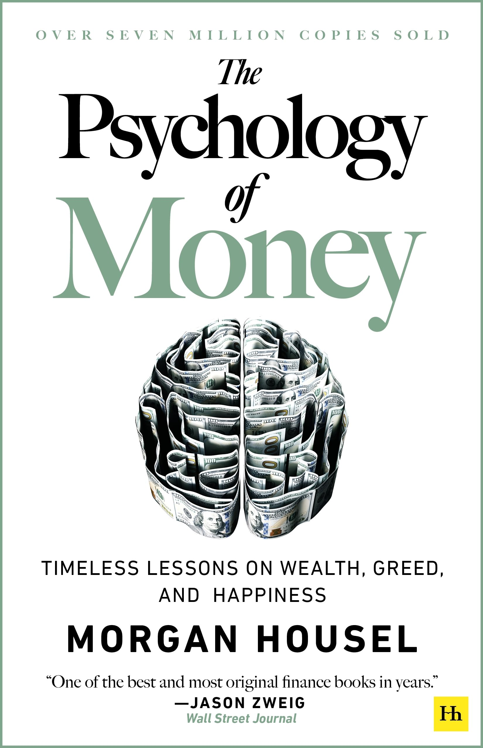For many affluent families, the mechanics of wealth—tax mitigation, estate planning, asset allocation, to name a few—are familiar topography. But even the most sophisticated strategies can be hastily undone by an overlooked variable: human behavior. That behavioral focus needs to be an evergreen theme for investors, advisors, and multi-generational families alike.

As you may have noticed, there’s no shortage of books about money. Most tell you what to do with it. A few try to tell you how to “beat the market.” And nearly all of them—whether from Wall Street strategists or self-anointed financial “gurus”—fail to address the one element that has more impact on your financial future than any portfolio allocation or tax strategy ever will:

**You.**

Not your job. Not your education. Not your net worth. Not your past returns.

**You. Your decisions. Your behavior.**

Reflections about our own discipline are rare and important—especially for our clients like you, who already have wealth and now face the difficult challenge of using it wisely and purposefully.

We thought it was important to share our lived experience advising hundreds and hundreds of families—because when you’re already

wealthy, what you need isn’t more intelligence or information. You need a reserve of relentless discipline.

**Behavior Beats Brilliance**

In the realm of professional advisory, especially those of us that serve the affluent, we spend a great deal of energy intermittently pretending that success is a function of intelligence, of shrewdness, of precision, of countless hours and sleepless nights agonizing over evidence-based methods to improve our clients’ investment returns.

Without discipline, all of that thought leadership and hard work devolves to mostly theater. Because the truth is that perhaps the most important driver of your long-term financial success is not your IQ (and admittedly, not even your wealth advisor’s IQ). It’s your EQ—your emotional discipline.

Our clients have no shortage of intelligence. Many have built companies, led teams, or managed complex professional responsibilities. And yet, we know for sure that financial success is not a direct function of intellect.

The key distinction, you ask? Behavior.

Behavior is what dictates whether someone holds steady during a volatile market or panics into a costly decision. It’s what governs whether someone lives within their means or chases an unsustainable lifestyle. It’s what determines whether someone honors their long-term strategy—or abandons it for the temptation of a trend. That’s because money isn’t just about spreadsheets and portfolios, but also choices, emotions, identity, and perception.

We need to be able to make the choice to:

* Sit still when the market is going haywire and all around you are panicking.
* Resist the siren song of speculation during a bubble.
* Accept short-term pain in service of long-term peace.
* Elect consistency over flashiness, adhering to a plan even when it’s not exciting.

Said plainly: the person who reacts, guesses, times, fiddles, and panics loses. Unlike much of what has made you successful, this isn’t about skill. It’s about self-mastery.

**Wealth Without Clarity: A Moving Target**

“Enough” is a very powerful concept—and underrated financial principle. “Enough” is not a limit—it’s a liberation. It’s the moment when money becomes a tool for life, rather than the other way around.

The difficulty lies in the notion that modern capitalism is really good at creating two phenomena: generating wealth and generating envy. For affluent families, the concept of “enough” can be surprisingly elusive. Not because your basic needs are unmet, but because the social comparison never ends.

One of the most damning lines in Housel’s book is also one of the shortest: “The hardest financial skill is getting the goalpost to stop moving.”

There’s always someone with a bigger exit, a larger yacht, a more exclusive club membership, or a more prestigious philanthropic board. And yet, chasing “more” without understanding what “enough” looks like is a recipe for financial overreach—and even worse... personal dissatisfaction.

Anecdotally, this mindset shows up in subtle and not-so-subtle ways. We’ve seen post-exit entrepreneurs who have already won financially but insist on recklessly wagering the bulk of their proceeds on doing one more deal. We see families that continue to escalate lifestyle expenses, unaware they unsustainably raise the reference point for future generations.

For those managing generational wealth, this principle is particularly crucial. Teaching heirs that financial strength lies in restraint, not display, sets the tone for stewardship. It reframes the family narrative from one of entitlement to one of responsibility.

Your advisor plays a critical role here. Helping you articulate your values and define what financial “success” truly means allows for more meaningful conversations about risk, liquidity, philanthropy, succession, and yes…even leisure. It gives us all permission to stop climbing, or at least to climb more intentionally.

But here’s the truth: if you don’t know what enough looks like, you will never feel wealthy. You’ll only feel restless. And the world will always be ready with someone flashier, faster, richer for you to measure yourself against.

The antidote to that disease is clarity. The quiet confidence that your wealth has done its job. That it now exists to serve your life, not define it.

**Real Wealth Is What You Don’t See**

Here is Housel’s observation, one we wish every wealthy person would tattoo onto their consciousness: “Spending money to show people how much money you have is the fastest way to have less money.”

Let that settle in for a moment.

We live in a culture where the definition of wealth has been completely inverted from generations before ours. In the eyes of the world, wealth is what’s visible: the houses, the cars, the clothes, the timepieces, the lavish parties, the Instagram photos, etc.

But in reality, wealth is what you don’t see. It’s the protective reserve you never had to touch. It’s the investment you let quietly compound for 25 years. It’s the estate plan that will one day create generational opportunity instead of chaos.

Anyone can look rich. We call that “all hat, no cattle.” But we’ve come to learn that you can’t fake liquidity. You can’t fake freedom. Wealth is not status. It’s optionality. It’s being able to walk away. To slow down. To say “no.” To spend your time with your grandchildren instead of your attorney.

Now, that doesn’t mean we shouldn’t have any fun or spend any money on discretionary experiences. That spending just needs to be congruent with one’s resources. That’s because true wealth is often invisible.

It’s the unspent dollar. The quiet reserve. The optionality created by not overcommitting. This has deep implications for high-net-worth individuals, as stealth wealth is not just a lifestyle, it’s a strategy. Families that keep a lower profile often benefit from reduced risk, lower social pressure, and greater flexibility.

The ability to act quickly, respond to opportunities, or weather downturns often depends on how much you’ve chosen not to spend.

We often remind clients that wealth isn’t just what you can buy. It’s what you can withstand. And that kind of durability is built quietly, prudent decision by prudent decision by prudent decision, over time.

**A Final Word on the Psychology of Money, From Us to You**

You’ve worked hard, invested wisely, and created optionality—but the real work isn’t over. The real work is the emotional work. The purpose work. The legacy work.

It’s asking:

* Am I behaving in a way that honors what it took to build this wealth?
* Do I know what enough means to me and my family?
* Is my wealth serving my values—or am I serving it?

We know that how you feel about your money matters more than how much of it you have.

And perhaps the most important question you will ask yourself: What do I want my money to mean? If you’re ready to dive into that deep end of the pool that is the psychology of money—we’re here for that conversation. Not just as wealth managers, but as stewards, as sounding boards, and as partners.

## *Securing Your Digital Life: What Every Family Needs to Know About Cybersecurity*

In today’s digital landscape, one of the most serious threats to wealth has nothing to do with markets, taxes, inflation, or recessions. It is digital fraud. High-net-worth families are often prime targets, yet many remain unaware of just how exposed their digital and financial lives have become.

Cybersecurity is no longer just a corporate concern. Personal email accounts, cloud storage, your smart TV, smartphones, and even your Wi-Fi-enabled garage door opener have become vulnerable entry points for attackers. A single compromised password or mistakenly clicked link can lead to identity theft, financial fraud, or even extortion.

So, what should you do? The same thing wise investors have always done: adopt a set of enduring principles and live by them with discipline. Below, we outline the major threats—and more importantly, the steps you can take to protect your wealth and your family.

**The Rise of Sophisticated Scams**

Gone are the days of obvious phishing emails riddled with spelling errors. Today’s cybercriminals use tailored, convincing tactics—known as *social engineering*—to target affluent individuals and their families. You may receive a message that appears to be from your wealth advisor, your bank, your accountant, or even a family member, requesting a wire transfer or login credentials. And if you’re not operating with a clear, consistent set of rules about what to trust and how to verify, you are living with unnecessary risk.

Always verify requests for sensitive information or financial transactions through a separate, secure channel. If you receive an unusual email from your advisor, **call a known number to verify verbally**. Never include sensitive data—account numbers, passwords, or legal documents unless encrypted and secured.

**The Front Door to Your Digital Estate**

Weak or reused passwords remain one of the most common vulnerabilities. Hackers use software to test billions of password combinations in seconds. If you use the same password for multiple services, a single breach could cascade into full access to your financial life.

Use a reputable password manager (Lastpass, Dashlane, 1Password, etc.) to generate and store strong, unique passwords for each account. Enable multi-factor authentication (MFA) wherever it is offered. This alone can block over 99% of automated attacks.

**The Weakest Link May Be the One You Love**

Many families invest in protecting their business systems but neglect the personal habits of spouses, children, or household staff. Yet, a teenager’s unsecured gaming device or a home assistant's voice commands can provide an unexpected point of entry.

Make cybersecurity a household priority. Educate all family members—especially those with access to shared devices or financial information—on safe browsing, suspicious links, and the importance of software updates.

**Phishing and Spoofing**

Some of the most damaging attacks stem from *spoofing*, where a malicious actor impersonates someone you know and trust: your CPA, your banker, even a family member. The message may look legitimate at first glance, but the underlying email address might be off by just a single letter or punctuation mark.

Before clicking on any link or attachment, check the sender’s email address carefully. If anything seems unusual—urgency, tone, or unfamiliar requests—pause and verify.

Remember: urgency is the language of fraud. A message laced with pressure or panic is a signal to slow down, not speed up.

Shape**The Bottom Line**

At Rockwood, you already know that we believe the greatest threat to wealth isn’t the market—it’s behavior. Emotions, assumptions, and unconscious habits can quietly erode what your discipline has built.

The same qualities that define successful investors—patience, discernment, and consistency—are equally important in protecting personal information.

Wealth invites both opportunity and exposure. In a world where cybercrime is increasingly sophisticated, staying calm and disciplined in your digital habits is your strongest defense.

Financial well-being today demands digital resilience. We’re here not only to steward your capital, but to help you protect your wealth and your family.

## *The One Big Beautiful Bill Act*

Congress recently passed the broad, vaguely named *One* *Big Beautiful Bill Act*—a tax and economic package that aims to balance deficit reduction with middle-class relief, environmental investment, and modest restructuring of the tax code.

While not as radical as some proposals in recent years, it matters. Not because it radically reshapes the tax landscape (it doesn’t), but because it subtly shifts the terrain in ways that will reward thoughtful, patient investors. It has quietly changed the rules of the game, so let’s walk through what it means for you—and how we’re responding.

The OBBBA enshrines into permanence many of the TCJA’s most favorable taxpayer features:

* The current seven tax bracket structure
* The increased standard deduction
* The 20% Qualified Business Income (QBI) deduction for pass-through businesses
* The enhanced Child Tax Credit

Let’s take a deeper dive into details of some of the updates.

**SALT Deduction Cap: Higher, but More Complex**

For years, high earners in states like California, New Jersey, and New York have been stuck with a flat $10,000 cap on state and local tax (SALT) deductions. The new law introduces nuance:

* Starting in 2025, the cap is temporarily raised to $40,000 for households with modified adjusted gross incomes (MAGI) of $500,000 or less ($250,000 for married couples filing separately).
* Phaseout for High Earners: The higher cap of $40,000 phases out for households with incomes exceeding $500,000. The deduction is reduced by 30% of the amount by which the taxpayer's MAGI exceeds $500,000, eventually phasing down to $10,000 for those whose MAGI exceeds $600,000.

Planning is important, especially if your income swings year to year, since the timing of deductions, the use of pass-through elections, and the deferral of income can meaningfully impact your after-tax return.

**Charitable Deductions Get a Very Subtle Haircut**

For the first time, the OBBBA sets a *floor* on the deductibility of charitable contributions equal to 0.5% of AGI, starting in 2026. This means that deductions are only allowed to the extent an individual's otherwise-deductible contributions exceed 0.5% of their AGI. There’s also a new cap on itemized deductions equal to 35% of taxable income for top earners.  
  
Not to worry, as we’ll navigate these new provisions using a precise combination of charitable bunching, donor-advised funds (DAFs), or qualified charitable distributions (QCDs) to maximize deductibility.

**Sunsetting of Clean Energy Credits**

The new law features a repeal of several ‘clean energy' tax credits originally introduced under the Inflation Reduction Act in 2022. These eliminations include:

* The Clean Vehicle Credit up to $7,500 for a new electric vehicle and $4,000 for a used one. OBBBA terminates these credits for vehicles acquired after September 30, 2025.
* Residential Clean Energy Credit. Up to 30% of the cost of purchasing or installing solar panels, wind power, geothermal heat pumps, or fuel cell equipment. The OBBBA terminates this credit for expenditures made after December 31, 2025, regardless of when the property is placed in service.
* Alternative Fuel Vehicle Refueling Property Credit. Up to $1,000 for electric vehicle charging equipment installed at a taxpayer's personal residence. This credit terminates for any property placed in service after June 30, 2026.
* Energy Efficient Home Improvement Credit. Up to $1,200 toward the cost of energy-efficiency improvements (e.g., windows, doors, insulation, or heating and cooling equipment, and home energy audits). Section 70505 terminates this credit for property placed in service after December 31, 2025.

To the extent that you have plans to buy an electric vehicle or undertake any of the above home energy improvements, it will be important to make sure the purchases or work are complete by the new deadlines to remain eligible for the credits. Some of these deadlines are just weeks away!

**Estate Tax and High-Net-Worth Planning**

In a surprise twist, the OBBBA raises the federal estate and gift tax exemption to $15 million per person—up from the current ~$13.6 million—and makes this level permanent.

**A Bill That Rewards Proactive Planning**

While the *Big Beautiful Bill* continues to grab headlines, the tax landscape remains widely the same. But for disciplined investors, its quiet changes are precisely where opportunity lives. Smart tax planning doesn’t come from reacting to headlines—it comes from understanding the fine print, aligning strategy with your long-term goals, and revisiting assumptions as the landscape shifts.

We’re already doing this work, and in the months ahead we will continue refining your plan to reflect these changes, whether it’s optimizing deductions, rethinking Roth strategy, or planning for intergenerational transfers in a multidecade view.

As always, if you’re facing a major decision (planning a significant asset sale, making a large gift, considering retirement) or have questions about how this bill applies to you individually, let’s chat!

[www.RockwoodWealth.com](http://www.RockwoodWealth.com)

(267) 983-6400

|  |  |
| --- | --- |
| **John R. Augenblick, MBA, CFP®, CEO** | **Kenny B. Bauer, EA, CFP®, Principal** |
| **Sam W. Feldbaum, MST, CFP®, Principal** | **Alaina M. Gilbert, CFP®, CPWA®, Principal** |
| **John T. Hagan, MSF, CFP®, Principal** | **Brian M. Hansen, CPA, CFP®, Principal** |
| **Mark T. Kelly, CPA, MST, CAIA, Principal** | **Megan J. Lottier, MST, CPA, Principal** |
| **Paige E. Marlow, Principal** | **Renee A. Schuster, MBA, CFP®, Principal** |
| **James A. Smith, Principal** | **Rob T. Stephenson, CFP®, AIF®, Principal** |
| **Robert M. Vogel, CFP®, Principal** | **Mark Arcidiacono Jr., CFP®** |
| **Geraldine Broadbent** | **John E. Collins** |
| **Maxwell V. Dalavai, CFP®** | **Courtney L. Durham, CFP®** |
| **Trey N. Dusek** | **Kimberly A. Evans, CFP®** |
| **Michael D. Flaten** | **Jack P. Gawason** |
| **Najeedah Ghias, CFP®** | **Hunter Gilmore** |
| **Erin Hahn** | **John Helvie, CFP®, DPT** |
| **Benjamin Herman** | **Joe Houk** |
| **Adam R. Klazmer, CFP®** | **Courtney Krzaczyk, MAcc, CPA, CFP®** |
| **Kristen G. Lepson** | **Jeff B. Llewellyn, MBA, CFA, CFP®** |
| **Elizabeth V. Loew, MBA** | **Leigh Machion** |
| **Jennifer L. Malinowski SHRM-CP** | **Phoebe A. O’Malley** |
| **Robert J. Maloney** | **Siddhi S. Malvankar** |
| **Jade A. Meier, CFP®** | **Catherine P. Morgan, CFP®** |
| **Kyle D. Quigley, MBA, CFP®** | **Tiffany Revels** |
| **Travis Roe-Raymond, CFA, CFP®** | **Natalia Rybak** |
| **Viviana Salgado** | **Carlie E. Shorr** |
| **Jack P. Ventresca** | **Patti A. Vidakovic** |
| **Jackson West** |  |

Rockwood Wealth Management, LLC (RWM), a Pennsylvania limited liability company, is a fee-only wealth advisory firm specializing in personal financial planning and investment management. Rockwood Wealth Management, LLC, is a US Securities and Exchange Commission Registered Investment Advisor. A copy of RWM’s Form ADV-Part II is provided to all clients and prospective clients and is available for review by contacting the firm. Indices are not available for direct investment; therefore, their performance does not reflect the expenses associated with the management of an actual portfolio. Past performance is not a guarantee of future results.